Car Data Collection

Instruction Manual

Last Edited:   02/12/21

Table of Contents

Introduction 3

Webcams 4

Layout 4

Installation Instructions 4

Starting Application 5

Selecting a Camera 5

Recording 5

Starting a new recording 6

Continuing a recording 6

Saving a recording 6

Notes 6

Seek Thermals 6

Empatica E4 Wrist Band 7

Diagrams of use 7

Starting up 8

Shutting Down 8

Charging 8

Notes 8

Data Upload 8

Viewing Data 9

Important 9

Biometrics 10

Vernier Go Direct Respiration Belt 11

Tobii Pro Glasses 12

# Introduction

This manual will provide a comprehensive document that outlines how to use the various sensors as well as provide suggestions for potential trouble shooting. The sensors include:

* Multiple Webcams running on the same device (The actual webcam is irrelevant)
* Multiple Seek Thermals running on the same device
* Vernier Go Direct Respiration Belt
* Empatica E4 Wrist Band
* Tobii Pro Glasses

We will be assuming that you are using a *Windows* device.

**IMPORTANT:** There are many devices that are about to be plugged into the computer. It is important that you connect the sensors one at a time. Test the new sensor each time one is connected because we found that often we improperly connect a sensor (e.g., accidently use a non-data transferring adapter). We also found that the powerful computer at school was unable to handle all the sensors while running applications so try to do this on a device dedicated to data recording.

# Webcams

In the following instructions I use the OBS screen camera for both the cameras, however, the same principle works for all webcams I have tested (various LGs, Microsoft surface 2 cameras, OBS).

## Layout

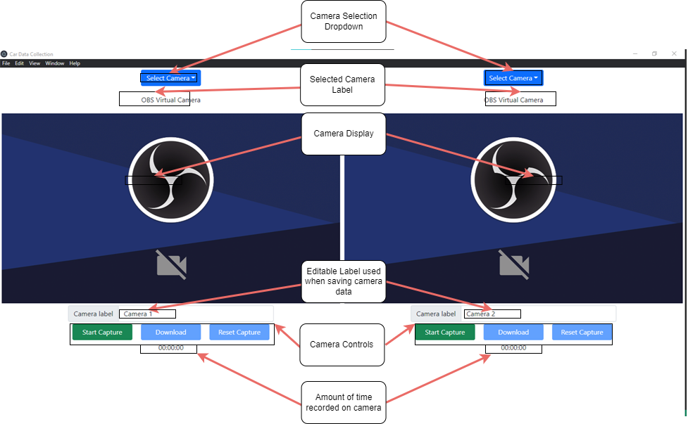

## Installation Instructions

1. Copy and paste the following embedded object onto your computer.



1. Install the application by double clicking on the exe file. The process should be somewhat quick taking only a few seconds on my computer.
2. The application should open automatically after installation. If it does not open, you can open it by searching for *car-data-collection* in the windows search menu or click the desktop icon.

## Starting Application

Plug in the cameras you want to use. The cameras **MUST** be plugged in before the application starts.

## Selecting a Camera

To select your camera, use the toggle button to change the camera below the toggle button. Every camera you have plugged in should be displayed. **Note:** it will take a few seconds for the display to update.

## Recording

Each camera display is independent, so each display must be started and controlled separately.

1. To begin recording click the *Start Capture* button. This will only start running 1 camera, and it may take a second to start.

1. When the recording begins the *Start Capture* turns into *Stop Capture* button. To stop recording click the *Stop Capture.*

1. The timer below the stop capture button is how long the recording has been running.



1. Pressing the *Stop Capture* button it will become the *Continue Capture* button. The *Download* and the *Reset Capture* will become active.

### Starting a new recording

You can press the *Reset Capture* button which will make it so the next recording is a new video.

### Continuing a recording

You can press the *Continue* button which will append new video to wherever the previous video left off.

## Saving a recording

1. After you have paused a recording, you can then press the *Download* button which will give a pop-up menu that gives you the option to choose the location of where to save the data of that camera. The recording must be at least 1 second.

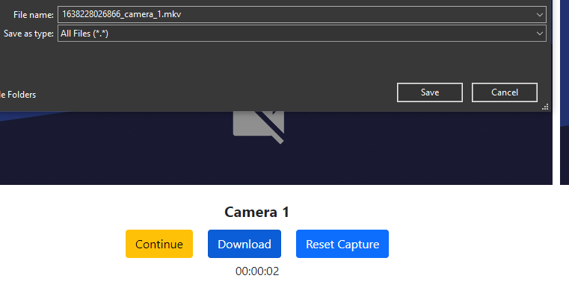

The given filename consists of two parts:

1. A Unix timestamp of whenever the video last stop recording.
2. The label that is below the video. You CAN edit this.

## Notes

* It will take a few seconds for the display to update when changing cameras
* The cameras mustbe plugged in before the application starts
* The recording must be at least 1 second, or there will be no downloading or resetting option when paused

# Seek Thermals

# Empatica E4 Wrist Band

*What follow is the instructions shared with us by Kathy with minor changes*

## Diagrams of use

## Starting up

1. Press the circle for **2 seconds only**
2. Blue light will flash for about 40 seconds- then will turn red
3. Green light underneath will glow, that means it is recording
4. Red light on top disappears

## Shutting Down

1. To stop recording press the circle on top for **2 seconds only**

Holding the button does other things...like resetting the watch.

## Charging

Yellow light indicates the battery is charging or that battery is low when it is not plugged in.

## Notes

* We will not use the E4 streaming feature.
* Holding the button does other things...like resetting the watch.
* While viewing Empatica data in the online session page, HR may not show on the graphs. It will still be present in the csv files.

## Data Upload

1. Open software on computer first
2. Connect wristband to charging cradle.
3. When clipping the charging cradle, be sure to snap it in in the right direction.  The 4 gold pins should touch the 4 gold plates (see figure below)

A picture containing empatic e4 heart rate band and charger


Connect to computer through usb port.

1. Process/sync and then access data through the E4 Manager app. This app is installed on the RA computer on the desktop.

|  |  |
| --- | --- |
| *username*: | acelabresearch@gmail.com |
| *password:* | SAV-ED2021 |

1. Opening menu displays tab to sync recently recorded sessions.
2. If you click on view sessions this will redirect you to Empatica’s website from here you can download data into csv files which we use for the analysis.

## Viewing Data

You can access all synced sessions via the cloud here:

|  |  |
| --- | --- |
| *link:* | <https://www.empatica.com/connect/sessions.php> |
| *username*: | acelabresearch@gmail.com |
| *password:* | SAV-ED2021 |

### Important

**Make sure you know exactly which session you are downloading from the online session page and resave that file immediately with the “subjectcode_sim_date”.csv**

## Biometrics

**Accelerometers (g)** - Artifacts can occur as a result of motion. The wrist band uses “photo plethysmography” which detects blood volume changes through light absorption. Movement can cause the light signal to deflect and will mess up the measurement. Events with high accelerometers are sometimes removed from the data for this reason, however should not be a great concern for our study.

**Interbeat interval (IBI)** – The time (in ms) between successive heart beats. This is used to create heart rate and heart rate variability measures.

**Heart rate** – in beats per minute. Value is estimated based off the IBI values.

**Epidermal activity (**μS/”microsiemens”) – Measurement of electrical conductance. This detects changes in sweat. It is thought that emotional activation, increased cognitive workload and physical exertion cause an increase in sweat. Skin conductance measurement is traditionally characterized into two types – tonic skin conductance level and phasic skin conductance response – which can roughly be thought of as “the smooth underlying slowly-changing levels” vs. “the rapidly changing peaks.”

**Blood volume pulse (BVP) –** This is used to identify the heart beats using photo plethysmography signals. It is related to IBI however IBI appears to be the measure always used to inform heart rate and HRV.

**Temperature (C)** – skin surface temperature.

# Vernier Go Direct Respiration Belt

# Tobii Pro Glasses

Using the Tobii glasses is quite easy, the downside is that when using it the computer must be connected to the Tobii’s wifi and will not have regualar internet access.